May 19, 2011
OPTIMIZATION OF CAPTURING EFFICIENCY FOR (g-2) EXPERIMENT E-989 AT FERMILAB

A new experiment E-989 is under development to measure the anomalous g-2 value of the muon, by a factor ~20 times more precise than the last E-821 experiment at Brookhaven [1]. The key element to achieving this is drastic improvement of efficiency of injection of muons into the ring. This includes more careful matching of the envelop and dispersion functions between the transport channel and the ring, improving performance of the fast kicker including improvements in the pulsed generator itself and geometry of the kicker plates. This also includes improvement in the control of the magnetic field integral along the ring in situ.
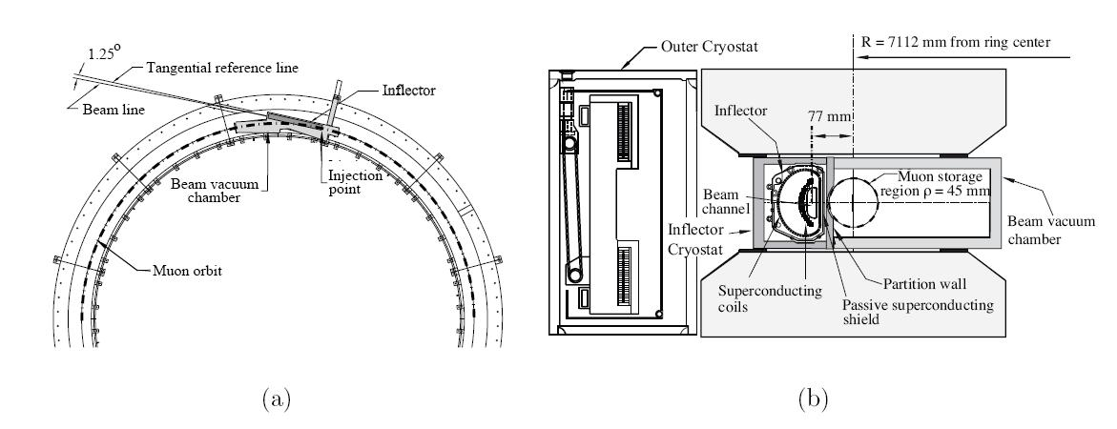
Figure 1. (a) –A plan view of the injection into the storage ring. (b)–An elevation drawing showing the inflector end where the beam enters the edge of the storage region, along with the beam vacuum chamber and the magnet pole pieces. Equilibrium orbit radius is 7.112 m [1].
During E821 kicker development, simulations of the injection and beam dynamics provided significant guidance on the importance of the various kicker parameters and were essential to the success of that kicker. Unfortunately, these calculations were not successful in reproducing the injection efficiency. New GEANT tools are now available that should permit detailed injection and kicker studies.
In Fig.2, four beam appearances are shown in the region of kicker after the beam has made four revolutions around the ring (Time of revolution~145nsec). While the pulse existence before the beam appearance in the ring is not important, the tail of the pulse acts on the beam. One can see that after the first kick is applied, the beam should be sitting on the equilibrium orbit. Meanwhile as the pulse still exists, on the second pass the kicker excites oscillations. The integrated action of the kicker pulse to the beam is rather complicated.

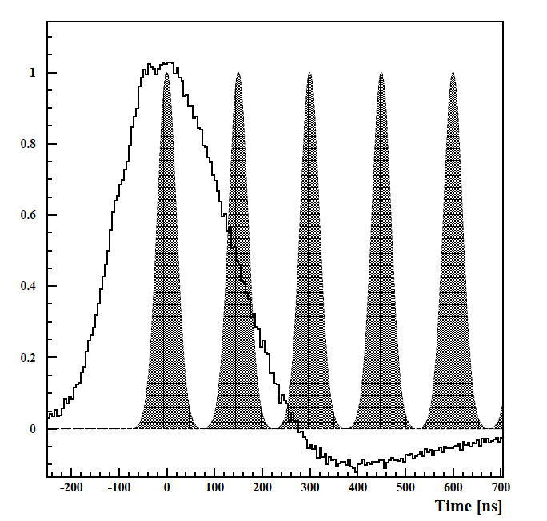
Figure 2. The structure of injected beam [1]. The trace is a sample kicker current pulse from one of the three kicker circuits. The periodic pulses provide a schematic representation of the unmodified muon bunch intensity during the first few turns. The vertical axis is in arbitrary units.

Sigma of injected beam can be estimated to be ~40 nsec .The beam revolution period is ~149 nsec. Beam appears in the ring every 11 msec. Parameters of the beam are shown in Table 1.

Table 1. Parameters of muon beam
Energy E_{μ} | 3.094 GeV
Muon lifetime at E_{μ} | 64.4 μs
Measurement period | 700 μs
Energy spread ΔE_{μ}
Bunch length σ_{b} | <50ns
Repetition rate | ~11 ms
Radius of equilibrium orbit | 7.112 m
Period of revolution T₀ | 149 ns (6.7MHz)
Spin frequency f_{a} | 0.23 MHz

PROGRAM OF RESEARCH AT CORNELL
Cornell has a lot to suggest for the improvement of efficiency. The program of research will involve the modeling of injection and the field establishment in a kicker, hardware design and fabrication. In the original E821 kicker development, a prototype of the vacuum chamber and the kicker electrode assembly was constructed. This was a replica of the full design with the exception of being straight rather than having the storage ring radius of curvature. We will move one set of the kicker pulser with controls and modulators to Cornell along with the prototype vacuum chamber and the kicker magnet and re-establish an operational system. David Warburton, who was in charge of the day-to-day development and operation of the E-821 kickers has expressed a willingness to help re-establish kicker operations.
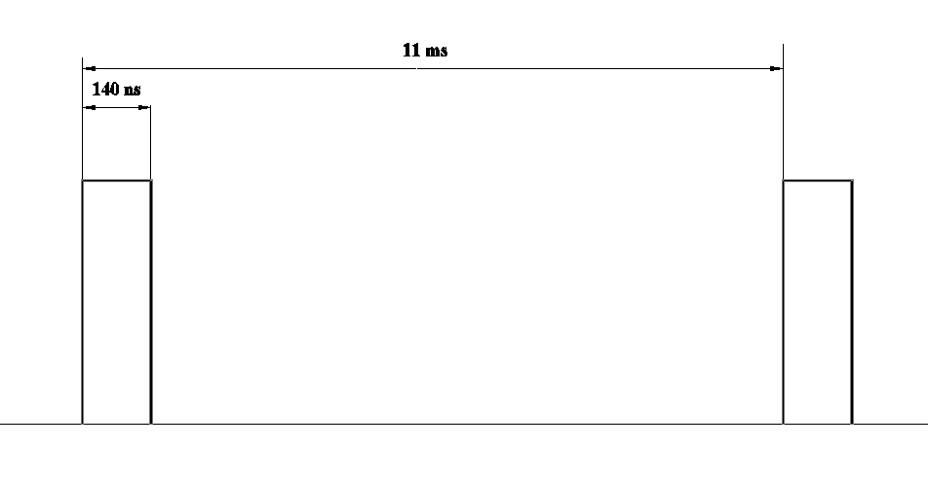
Figure 3. The pattern of the kicker pulse desired.

Optimization of injection optics
Injection process of muons governed by the proper positioning of particle to its equilibrium orbit, defined by the energy of muon. We will match the dispersion function in a channel and in the ring. The higher the energy, the larger the equilibrium radius is. This can be described by the formula of momentum compaction
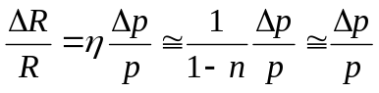, (1)
where 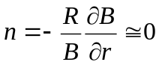 for the case of (g-2) ring, so dispersion function should be R=7m.
Energy acceptance of the ring becomes Δp/p= Δ R/R= 1.2·10⁻³.
The envelop functions between the Debuncher and the g-2 ring are represented in Fig. 4. One can see that the dispersion function becomes zero in a current optics design. So, potential for improvements should be investigated more carefully.
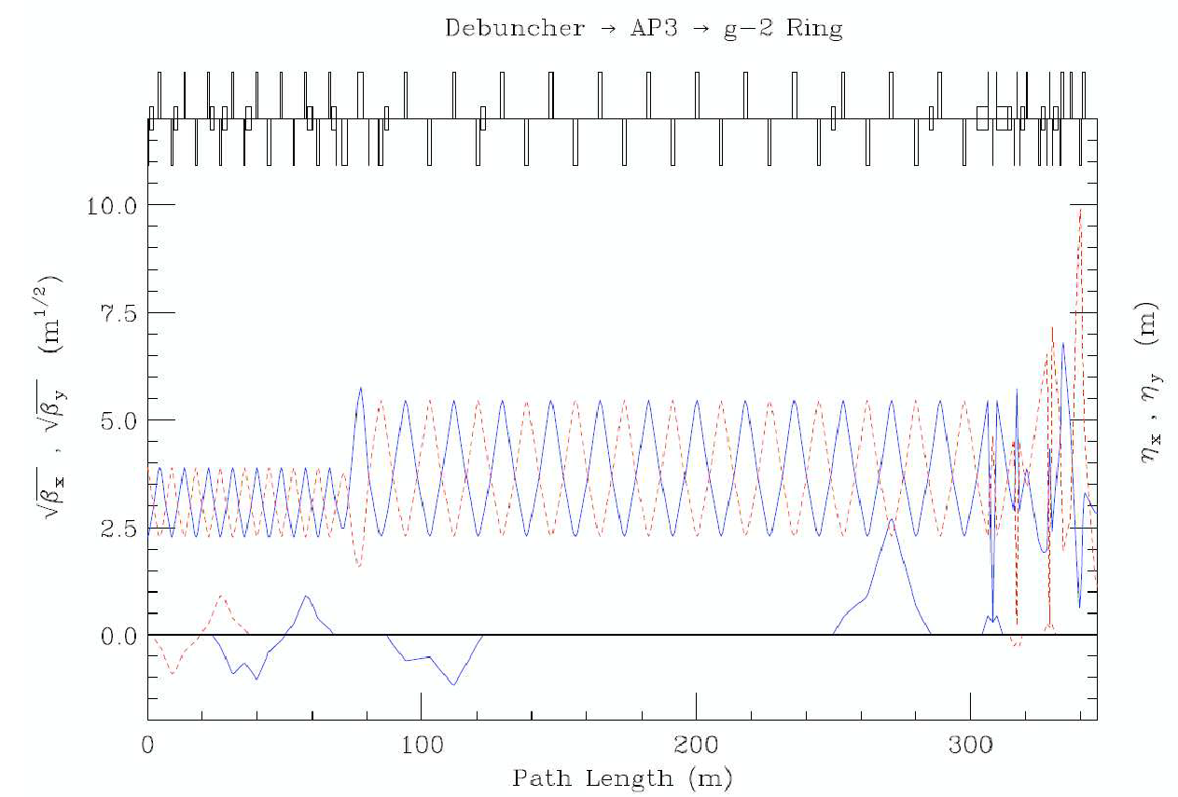
Figure 4. The envelop functions and the dispersion function in existing optics design [1].
Appropriate kick
Dependence of the amplitude of the kick on the radius of aperture.
As the particle with higher energy sets on the bigger radius, then the angle to the equilibrium orbit is smaller too; however the kick required for the particle with higher energy required is bigger also, so these effects might cancel each other in the first order. So, the homogenous field distribution might be appropriate if the dispersion function chosen as necessary.

We will optimize the value of dispersion function and match it with the transport channel.
So far, the integral of magnetic field in a kicker required is 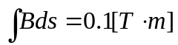. For a 5-m long kicker this comes to the field in the kicker equal to
. (2)
If we suggest that the effective height of the kicker plates is h~10cm, then the feeding current should be
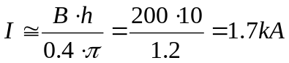. (3)
The HV thyratron can run up to 6 kA even in a long duty circle, so a single thyratron can feed three kickers in parallel.

Arrangement the second set of kickers at diametrically opposing location
As the gradient across the aperture is ~0, the n=0 , and the betatron tunes
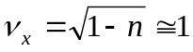, 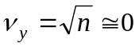 (4)
This place is free from quadrupoles, so there will be not a problem to install additional kickers at this location.

KICKER MAGNET
First we analyze the existing geometry and the existing Pulsed generator. For analyses of magnetic/electric fields we will use the 3D MERMAID and FlexPDE codes.
Freedom of choice the cross section of electrodes affected by the system of trolleys, caring the cartridge with a set of NMR probes (17 total), sees Fig. 5. This cartridge runs inside the chamber a few times per week (typically 2-3). If redesigned, the NMR trolley should take into account modified geometry of the kicker plates.
Only three of the four sides of the vacuum chamber are shown in Fig. 5; the inner radius (right-hand) side is missing. The kicker electrodes are shown supporting the NMR trolley (the body of which has a circular cross section). The fixture on the lower right (at 4:00 on the trolley body) supports the forces needed to move the trolley, and the cable is attached to the bottom of this “C” shaped fixture. The high voltage standoffs are made of macor, as are the top and bottom plates which have recessed holes to secure the standoffs. The top and bottom plates, along with the vertical supports and the kicker electrode-standoff assembly, form a rigid cage assembly.
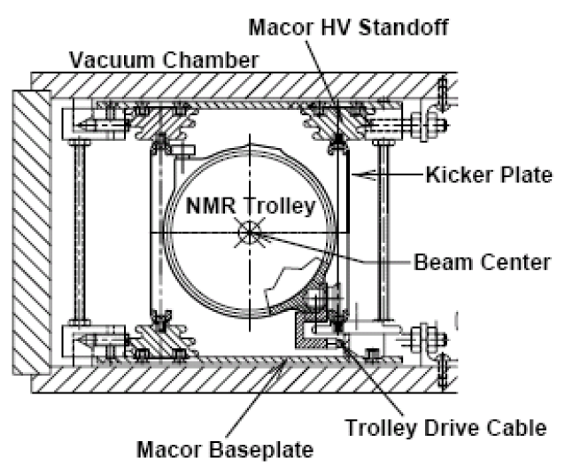
Figure 5. Cross section of kicker with NMR trolley system of E-821.

The kicker plates are 80mm high, 3x1760 mm long (three sections in series fed by a single generator), 0.75mm thick. The plates are 102.24 mm apart. The NMR trolley is 88 mm in diameter [1].

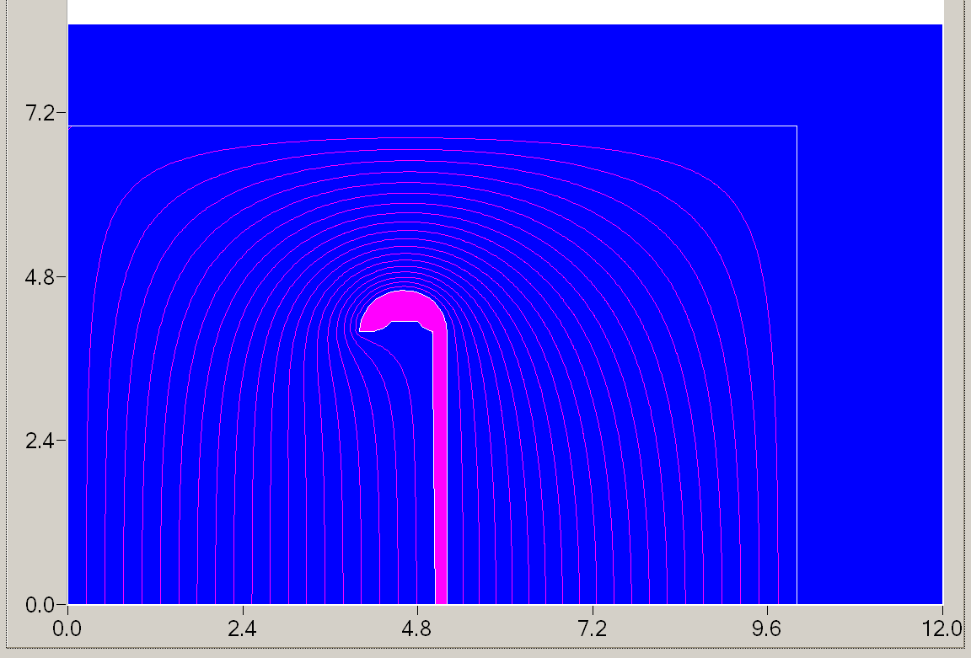
Figure 6. Magnetic lines in the old kicker (MERMAID). Center of the beam orbit has the coordinate (0,0). This distribution is established when the feeding pulse has finished its run form the entrance to the short end and back. This distribution is established right after the bi-polar pulse enters the kicker.
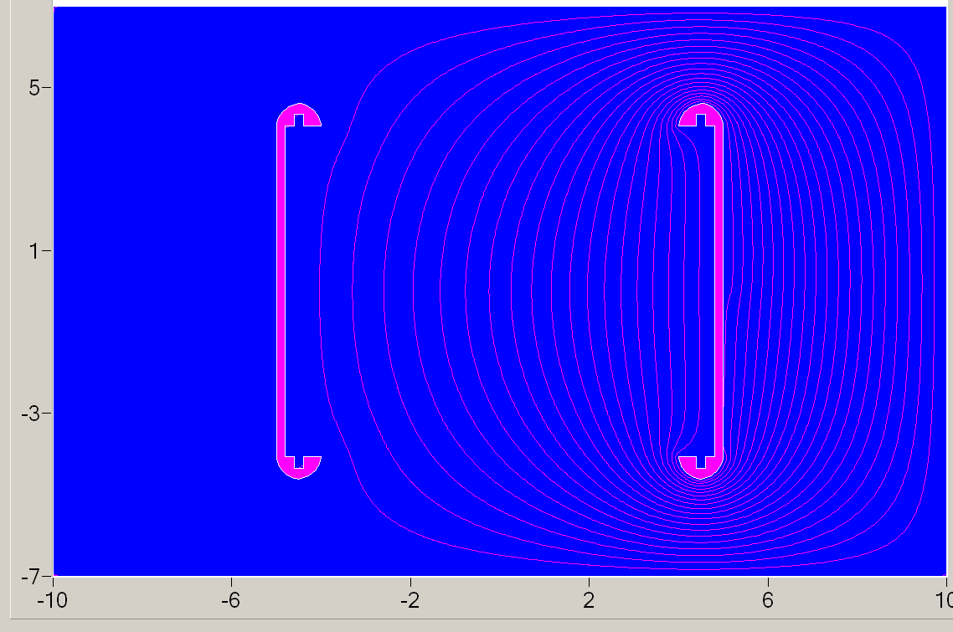
Figure 7. Magnetic lines in the old kicker. Center of the beam orbit has the coordinate (0,0). This distribution obtained in assumption that opposing plate has ground potential, the same as the boundary.
One can see from Fig.6, that the lines are concentrated in tight places, so the input in integral 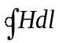 is bigger at these locations, so the field in the region of interest (central one) is reduced. Careful reconsideration of geometry and the way of feeding the plates is required. One way is to insulate the opposite plate from the ground (vacuum chamber) and feed it independently. This will be resolved in our work.
We shall calculate the input of nonzero susceptibility of Aluminum and Copper electrodes and structural elements to the field homogeneity also (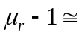+2.2·10⁻⁵ for Aluminum, for Copper -0.92·10⁻⁵). Skin depth of field
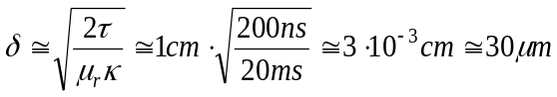 , (5)
where 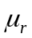 is magnetic permeability, is specific resistivity and it was taken into account that for 50Hz (20 ms) the skin depth in Copper is ~1 cm.
The E821 kicker field was not able to kick the beam optimally. Even at the maximum high voltage (limited by breakdown) the number of stored muons had not plateaued. (This needs to be better quantified.) The resulting coherent beam motion from the under-kick also introduced a systematic error on the muon frequency [5].
It is not clear from the materials available, if the NMR trolleys rails are arranged in a closed loop above the kicker plates; so this may affect performance of the kicker significantly.

Optimization the geometry of a stripline kicker.
Stripline kicker represents for the moving EM front not the inductance only, but the capacity as well. Therefore, its impedance is active for the propagating wave front. The voltage across the input of kicker plates exist for the time duration, which is equal to the time required for the wave to propagate to the shortened end and back:
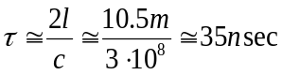. (5)
During this time, the kicker does not provide the right kick, just its fraction, defined by the position of the beam with respect to the pulse. While propagating to the shortened end, the kicker does not kick the beam at all, as the action of electric and magnetic fields cancel each other. Factor 2 appears as a result of propagation of the muon beam towards the front of the pulse with speed close to the speed of light. So making sections shorter allows for improvement in the effectiveness of kick.
So splitting the present three sections in independently feeding units will allow to cut this dead time three times, coming to ~10 nsec.

Make electrodes more compact and strong.
Pressure acting to the plates of kicker is defined by the magnetic field value. If a grounded surface (inner surface of vacuum chamber) is far from the plate, then the pressure can be evaluated in the first order as
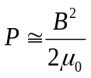, (6)
where 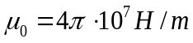 stands for the magnetic permeability of vacuum; B, Tesla, - is a magnetic field between the plates. For the reference, 1 T field generates the pressure ~ 4 atm or 4kg/cm² . For a typical peak current 4000 A, one calculates the field amplitude at about 140 G at the center of muon storage region [2]. So the pressure acting on the plate comes to 4x(0.14/10)²~8x10⁻⁴ atm, coming to ~4 kg total for the full three sections of kicker (3x1.76x0.1m²=0.53m²=5.3·10³cm²) The kicker plates are 0.75 mm thick, so they can withstand this short pressure rise dynamically, taking into account the short time of the field action. Definitely, some attention to this effect is required.

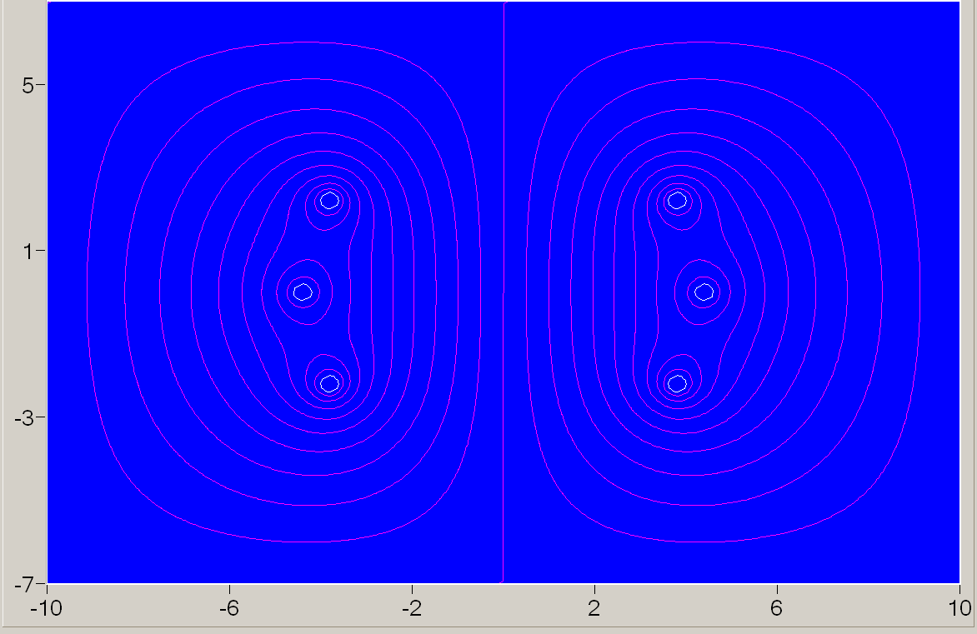
Figure 8. Magnetic lines around one variant of suggested kicker modifications [5].
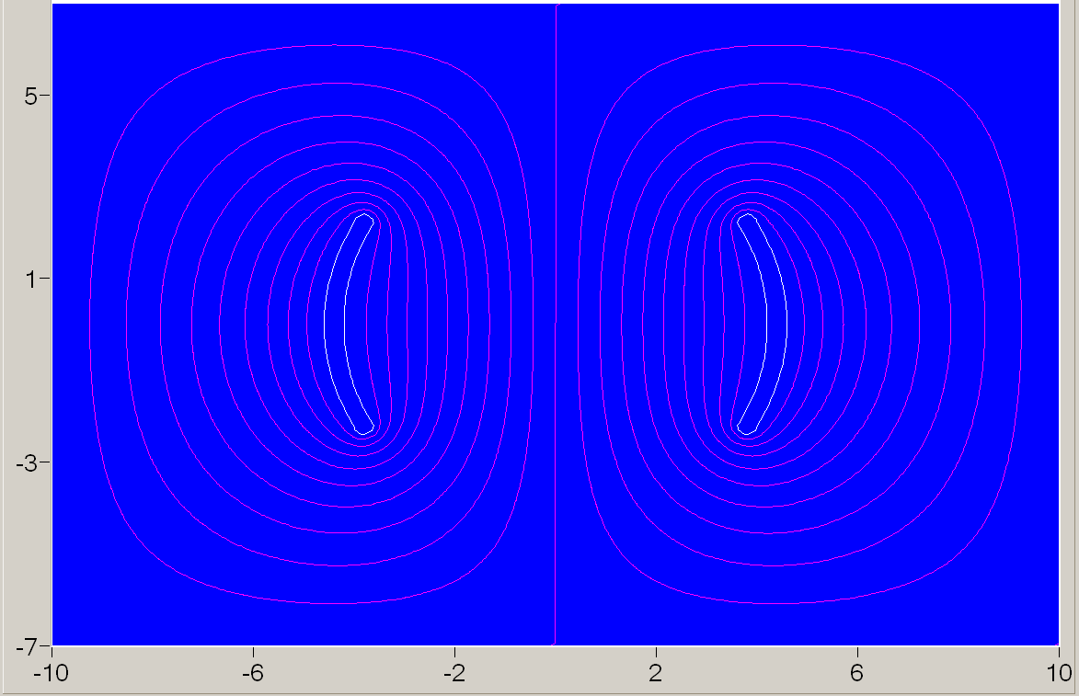
Figure 9. Another profile of electrodes.

Make the impedance of the stripline kicker as low as possible;
Lower impedance yields lower voltage for a given current that runs in the plates.
Make the field distribution either more homogenous or with appropriate dependence on the transverse coordinate, if necessary by injection.
Choosing of materials should be done carefully, taking into account nonzero susceptibility. Stray fields in surroundings are another subject for research. Good conductors allow reduction of the fields capture in a skin layer, but circulation time for the currents captured in a skin-layer becomes longer, so careful analyses required here.
Consider the electrodes to be retractable, allowing the NMR cartrige to run during measurements. As there is a plan to re-design the trolley drive to accommodate the new geometry of electrodes, it is possible to make improvements in geometry of kicker as well.
Again, avoid closed loops of trolley rails above the kicker.

OPTIMIZATION OF THE PULSE GENERATOR
Existing generator
First let we analyze the existing generator briefly. The principal scheme of generator is represented in Fig. 10. The high-voltage capacitor (10nF) is charged resonantly and then the thyratron is fired to produce the kicker pulse. The modulator is filled with Dow-Corning 561 silicon dielectric fluid.

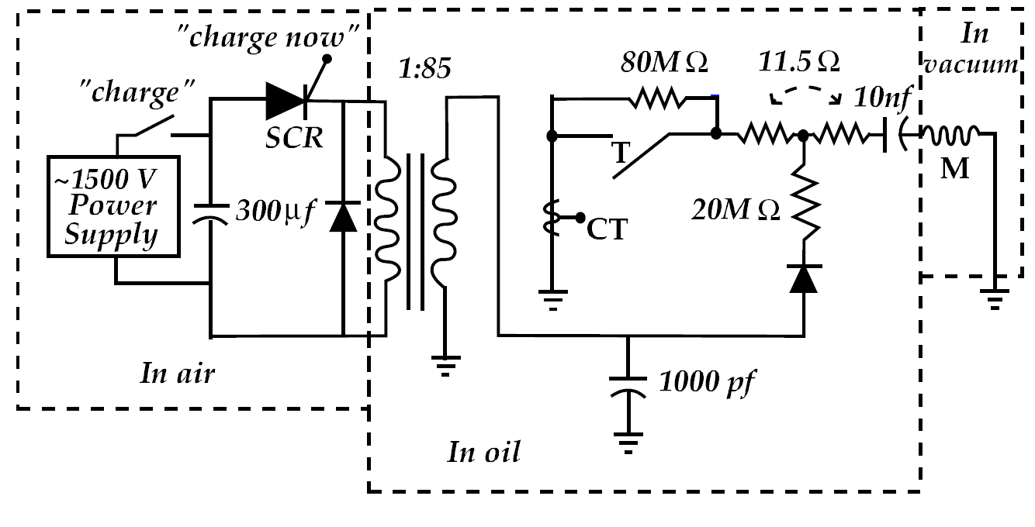
Figure 10. Principal scheme of existing generator, used in E-821 [1].

With the inductance and resistance obtained from the physical assembly (including the thyratron), each modulator delivers a current pulse of approximately 4200 A with an initial voltage of ~95 kV on the capacitor.
The E-821 kicker modulators did not have external cooling. The heat generated was small enough that the oil in the modulators could dissipate the heat from convection in the oil, and then the entire structure, while a little warm, did not increase significantly in temperature. With the higher repetition rate necessary at Fermilab, it will be necessary to add cooling and circulation for the silicon oil. One question to be determined by R&D is whether the heat can be taken out of the carbon resistors rapidly enough to keep them from failing.
It is clear from Fig.10, that during the firing, the voltage drop across resistor comes to 4200Ax11.5Ohm=48.3 kV i.e, a substantial value. Such value of resistor defines the RC time constant RC=11.5 x 10⁻⁸ = 115ns; this is a minimal time duration which can be obtained with this generator. Lowering this resistor removes discharge from aperiodic regime, however, so the accurate optimization required here.
Radical way –to consider a matched line option for the kicker.

Characteristic frequency of LCR circuit is defined by the expression
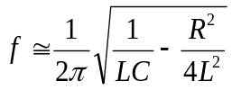 . (7)
So if the expression under the square root becomes negative, the discharge is aperiodic. For parameters of inductance measured, R_{cr}≈ 25.3Ω , so the resistor in Fig. 8 scheme is twice smaller, than this limit.

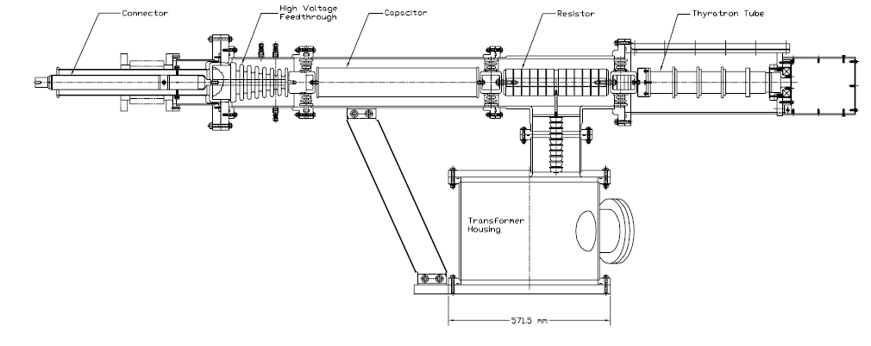Figure 11. Realization of the scheme from Fig.10.

So the scheme used in E-821 is robust and satisfied the series of measurements carried at BNL; it could serve as a baseline for further developments.

To the choice of pulse generator
Scheme used in E-821 is the simplest LCR circuit, which is represented as a) in Fig.12.

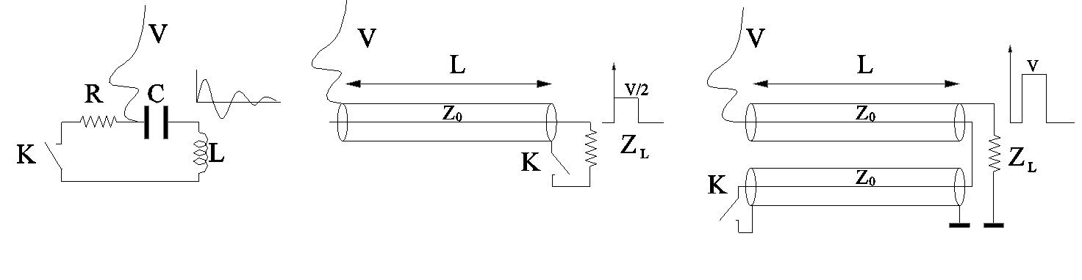
a) b) c)
Figure 12. Different schemes: a) E-821; b) Matched line; c) Blumlein transmission line.

In all schemes, the charging voltage is applied through the limiting impedance (inductance, resistor) so while triggering, a shortage of power supply does not happen.

RCL generator; a) in Fig.12 (E-821)
Usage of this type of pulser is justified for the short kicker, so the time required for the wave to travel through the kicker could be neglected if compared with the pulse duty. The characteristics important for the discharge process are described in the above section.

Single line; b) in Fig.12.
Impedance Z_{L} equal to the impedance of the kicker line Z_{0.} In this case the matching impedance installed at the end of the kicker plates provides no reflection. For this type of matching the electric and magnetic field act together to the counter-propagating beam. The pulse width is twice the tame taken by EM wave to travel to the end of the line and can be expressed as the following
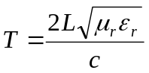 (8)
where L is the length of line (see Fig. 10) , 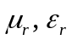 stand for the relative permeability and permittivity of material of the line respectively, c is a speed of light. For a typical cable, the 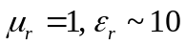 so the 3m –long cable provides the time duration 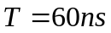.
If the line impedance is Z₀, the impedance of the kicker line Z_{L}, then the output voltage comes
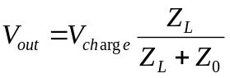 , (9)
Voltage appearing at the output is ~half of the charging voltage, if the impedances of the line and the kicker equal each other. The pulse appears on the load right after the switch is triggered; again, it has amplitude ~1/2·V_{charge}.
Blumlein transmission line; c) in Fig.12 [6]
Usage of Blumlein allows doubling the output voltage in a modified generator, practically in the same hardware. The output voltage comes
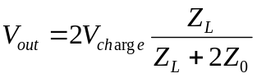 ; (10)
in case 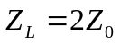 the output voltage is equal to the charging one. The pulse appears on the load after the time required the wave to propagate along the line.
Different topological modifications of this scheme are possible, so the choice of the proper one will be the subject of our research (see Fig.21 below).

Scheme for doubling the output voltage on capacitors.
For the scheme in Fig.13, the inductance l<<L . Capacitors charged as it is shown in Fig.13 a). In this case, after the switch K is closed, the lower capacitor recharged quickly, in 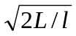, faster than the discharge through the load L, see Fig.13 a). As the switch chosen can transfer the current in one direction only, after recharging it becomes open and about doubled a voltage applied to the load inductance L. The voltage which the thyratron should withstand is half of the output one, so it is rather positive peculiarity.
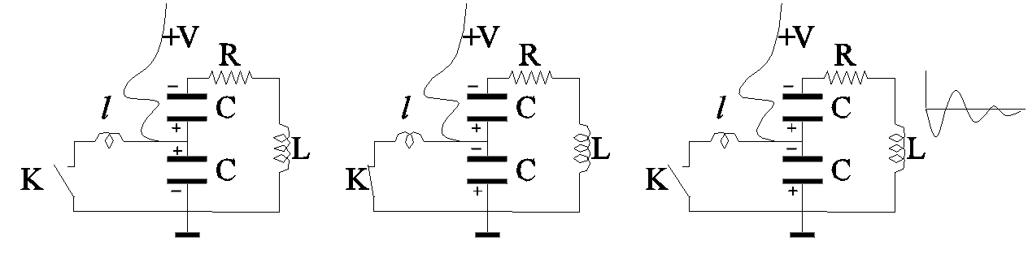
a) b) c)
Figure 13. Doubling the voltage with capacitors. The switch K is transferring the current in one direction only (thyratron, thyristor). Inductance l<<L.

The output current in this scheme
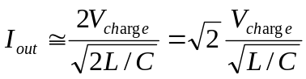 (11)
is about 1.4 times bigger than with a single capacitor, (a) in Fig.13. Naturally the value of capacitor can be doubled also, so the gain in a current can reach two times.
Some resistor might be required in a circuit of switch in addition to the inductance l for the limiting the dI/dt to the acceptable level (resistor not shown in Fig. 13).
A low inductive resistor is made from the volume dissipation one or the one made from many high-resistant wires bent in a zigzag shape, so the inductance becomes reduced, see Fig.14. The wires are located in a non-conductive carcass; this type of resistor is able to dissipate substantinal power.
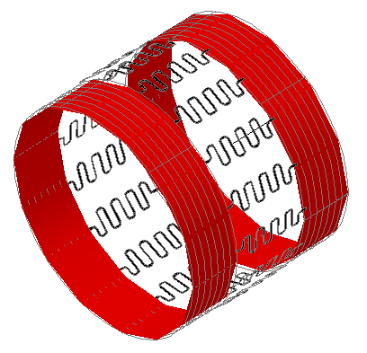
Figure 14. Low-inductive resistor concept.
Investigation of this scheme might be the first step in development of the pulser, as it requires minimal modification of existing generator.

Bipolar (para-phase) feeding allows doubling the kick.
We are considering the shorter kickers with less bulky generators also. Some additional electrodes inside the vacuum chamber of the ring can help in matching impedances. Wrapping the inner place of vacuum chamber in location of kicker with high conducting materials with the thickness bigger, than a thickness of a skin-layer, can help is reduction of losses in a kicker and in reduction of the stray fields. For preparation of the bipolar pulses the inverters are used, see Fig. 15.
Switching polarity in the kicker might be required for accumulation of muons with opposite sign of charge.
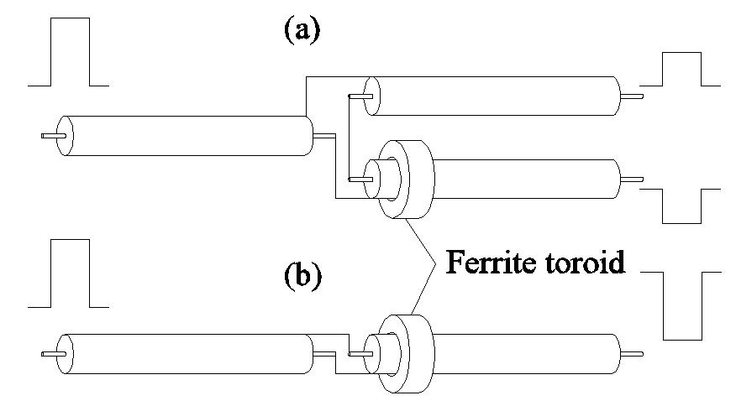
Figure 15. Schematics of inverter with a split (a), simple unipulse inverter (b). These schemes are working in both directions.
A transformer made from coaxial cable can serve for inverting polarity also.
Charging the pulser
In a charging scheme of E-821 kicker pulser, the thyristor switch is used, (see Fig.10). Usage of thyratron with the transformer having lowered stray inductance and fewer turns, allows to shorten the charging time. This will help in prevention of sparking, as the system will be hold under the high voltage for a shorter time duration.
Some attention should be paid to the charging circuit. Although the charging of capacity in a scheme from Fig.10 is going through the kicker, the beam is absent at this moment (not injected yet).
Energy stores in the capacitor C=10nF in Fig. 7 for V=100kV is
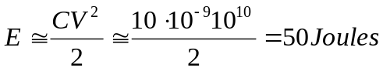 , (12)
which is not big. As this energy is dissipated and the PS charges it again every τ=11 ms, the power required from the PS, comes to
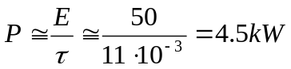 . (13)
High voltage charging transformer concept is shown in Fig. 16. The primary winding is made as a wrap around the laminated core cut along one side to prevent from closing the loop. The secondary windings could be made with double wire windings to deliver a pair to the high voltage potential, if necessary (to supply a thyratron heater for example).
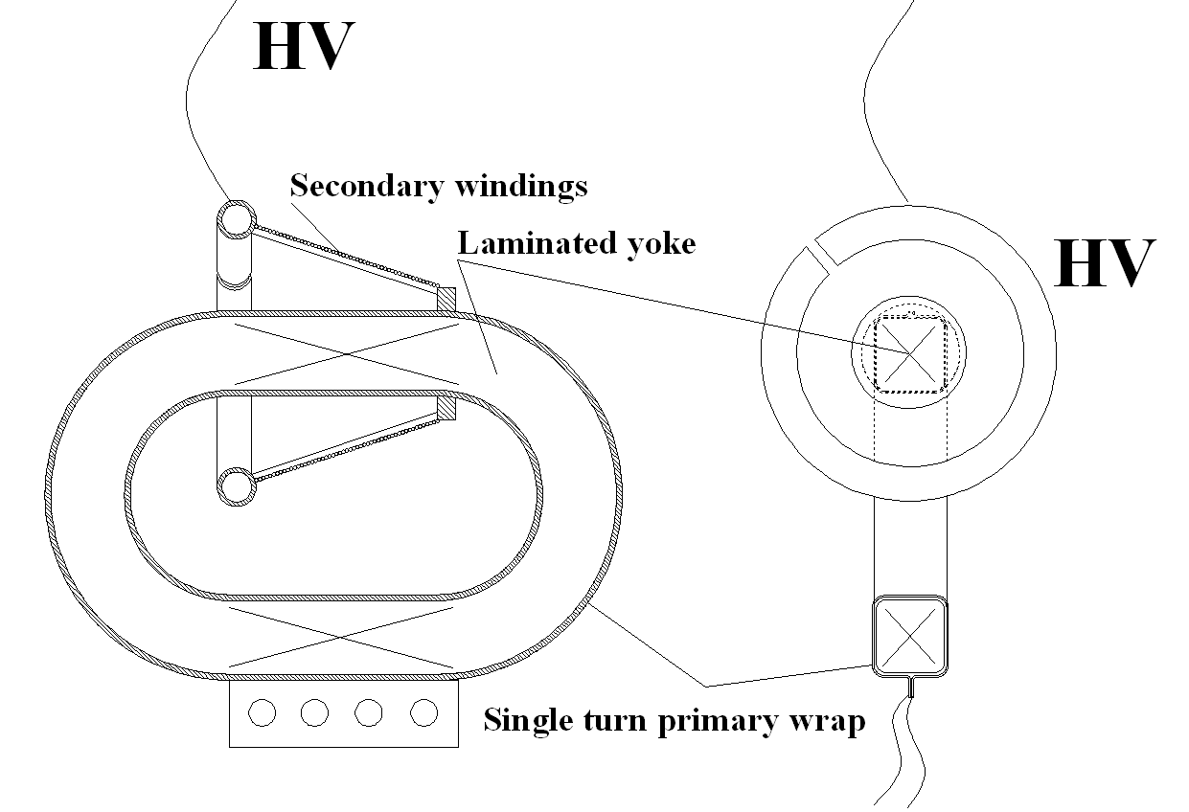
Figure 16. The concept of the charging transformer.

Tapered matching transformer
If transmission line has some space available, then the change in its impedance can be used as a transformer for the pulse.
To drive a specific voltage in a strip-line kicker, the voltage in a pulse required is just V=IZ, where Z stands for the impedance of the line. Typically it is 30Ohm, so if the generator is able to provide current I=4kA the voltage could be developed comes to V~120kV. So usage of transformers might be beneficial here. Equations governed propagation of the pulse in a tapered transmission line are the following:
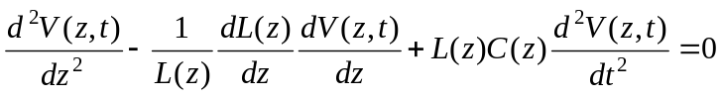 (14)
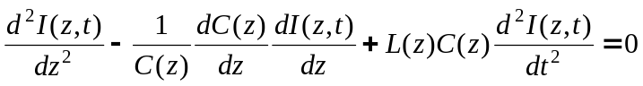 (15)
where V(z,t) stands for voltage and I(z,t) for current at local position z along the line, L(z) and C(z) are local inductance and capacitance per unit length accordingly. Solutions of these equations are the following
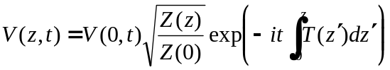 (16)
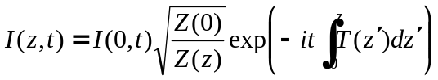, (17)
where 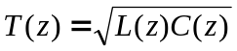, 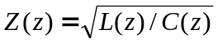. The last expression is a characteristic local impedance.
The preferred schemes for investigation at the first stage.
So we begin with modification of existing scheme from Fig.10. The scheme shown in Fig. 17 a) is the same as in Fig. 11. It differs from the scheme of E-821, Fig. 10 only by the addition of capacitor C₂. Some additional elements are: L_{s} –saturated choke. Z_{rch} is an impedance, limiting dI/dt, D_{ch} stands for charging diode. HV transformer has a transformer ratio 1:40, less than in the original E-821, as we suppose that lower the transformation ratio-less influence of stray fields in a transformer will be. Charging primary capacitor C_{ch} is going with resonant scheme, which includes the choke inductance L_{r} and capacitor C=300μF : every pulse the voltage from this capacitor adds to the voltage of power supply. So the 3.5 kV PS is able to generate effective voltage on C_{ch} higher than 3.5 kV and defined by the losses in primary charging loop only. Recharging C_{ch} is going through the transformer, this helps in its demagnetization. This concept in use at the Cornell positron source pulsed lens.

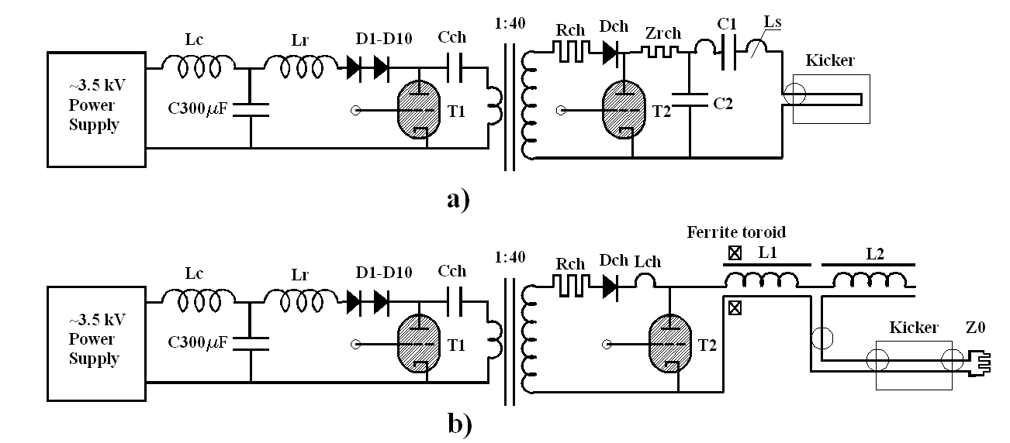
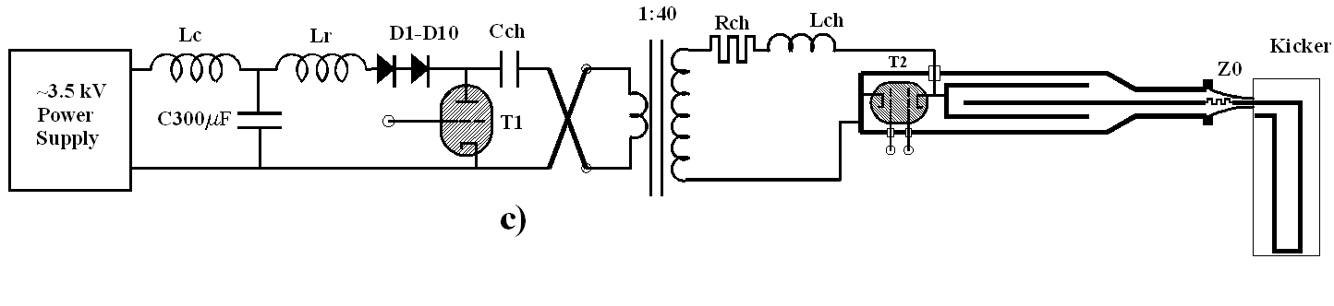
Figure 17. Schemes of the pulse generators. a)–with additional capacitor C₂ , b) – Blumlein transmission line, c)- full scheme suggested (see Fig.21).
So at a glance the scheme with doubled capacitor (Fig.13) can be investigated in more detail; it is very close to the original E-821 generator. The Blumlein generator has much bigger potential for the improvement in the pulse generator, just by modifying existing hardware a little.
Scheme b) in Fig. 17 is a Blumlein generator with artificial transmission line. The charging primary circuit is the same as in the scheme a). Ferrite toroid serves for electrical insulation of the left end of the artificial line. R_{ch} stands for the charging resistor in both schemes.
Sheme in Fig.17 c) uses a bipolar thyratron and switchable polarity in charging transformer. This scheme allowing generation of bipolar pulses what could be very useful for switching between positive and negative muons.

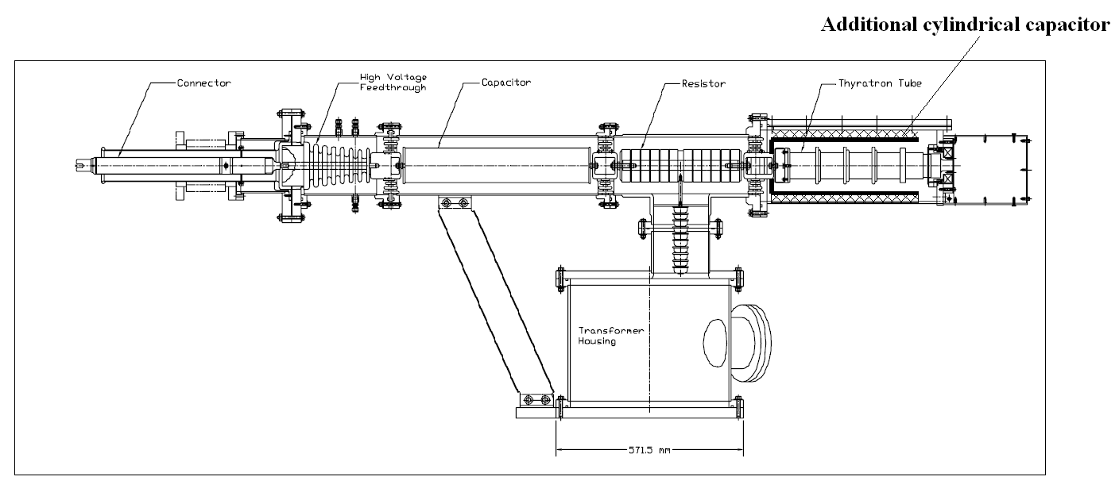
C₂
Figure 18. Modification of the hardware from Fig. 8
The capacitor can be realized as individual HV RF ones installed on the surface of a cylinder, or as a homogenous unit with dielectric filling.

PERSPECTIVE SCHEME
The Blumlein scheme can be transformed into a three-axial line as it is shown stage by stage in Fig.18.
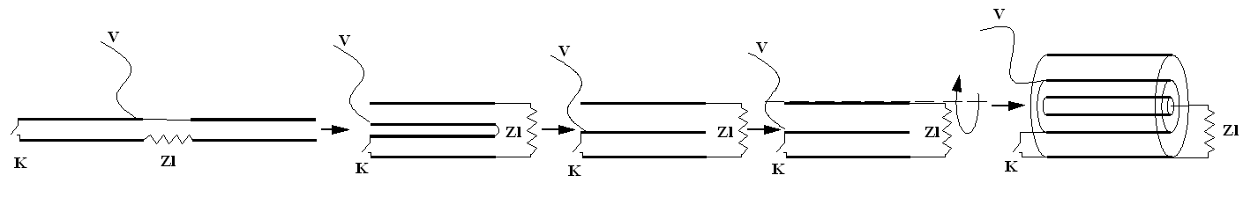
Figure 19. Topological modification of Blumlein transmission line into a three-axial line (One can choose the rotation axis coinciding with the lower plate).
Such three-axial line allows for a compact design of the Pulse generator, shown in Fig. 20.
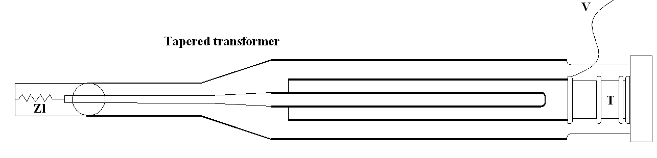
Figure 20. Blumlein generator in a three-axial realization. Thyratron can be oriented in the opposite way for generation of pulses with opposite polarity.
Scheme from Fig. 19 can be considered as a perspective for improvement of the pulse generator.
Diameters of electrodes should be adjusted to match the impedance 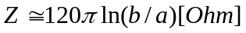, where b/a is the ratio of diameters. One can see that some hardware from the generator in Fig.9 can be used for prototyping the generator from Fig.19.
All volume can be filled with transformer oil or even with Ferrofluid, making the line shorter and for the cooling purposes. Ferrofluid permeability can be ordered, varies from 10 to 900, so the length of the line can be for 140 ns pulse duration and μ_{r}=10, ε_{r} =10, according to (8), as short as
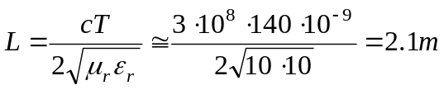 , (18)
i.e. extremely compact one.
We would like to underline, that for the generators loaded by matched impedance the distance between the pulser and the load is not limited, but defined by the losses in the connecting transmission lines (coaxial cables), which are small. So one can imagine the distance of few tens of meters; the generators can be located in a protected compartment allowing access with the beam in the ring. In addition, usage of highly pressurized three-electrode spark chamber instead of the thyratron allowing having the rise time and decaying time of the order of 2ns, but this is out of the scope of this project.
One can see that substantial potential exists for development of this scheme.
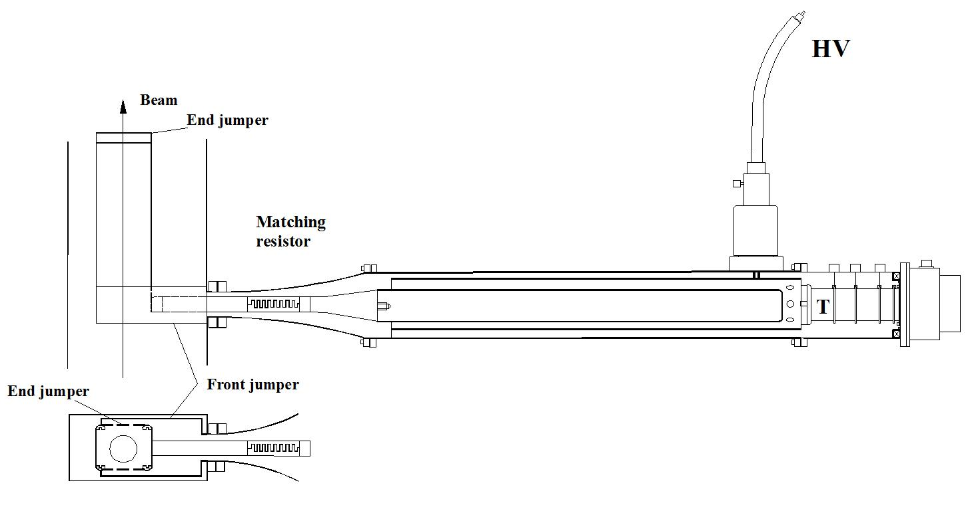
Figure 21. Suggested pulser with the shorted end (as it is in E821).

In scheme represented in Fig.21 the pulse generator is loaded by the matched resistor to avoid reflections. Its value is twice the impedance of the Blumlein transmission line. This type of resistor represented in Fig.14.
At the first stage we suggest to switch polarity with inverter shown in Fig. 16. It could be done mechanically. At second stage, if necessary, we can suggest an electronic switching system with an additional thyratron. One can see that if the switch K in Fig. 19 located at the other side of the line- then the output polarity will be opposite.
Bipolar feeding has obvious difficulty which is- very limited access to the inner side of the vacuum chamber. We suggesting making a round hole through the cryostat and the magnet yoke, see fig 22. As this hole is localized, there will be not a problem to arrange cryogenically acceptable pass through. Other solution- to make the jumpers to the inner plate will be very difficult as the space between the plates and the inner chamber is limited. Substantional design work and 3D calculations will be required in this case.
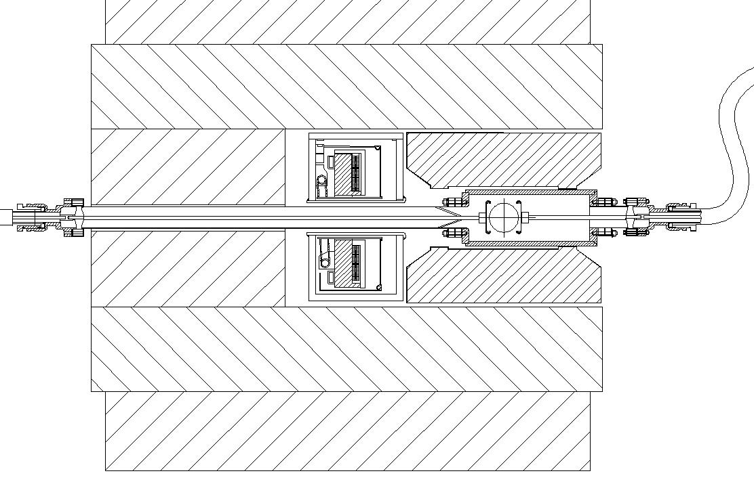
Figure 22. One suggestion on how to arrange the bipolar feeding of kicker.

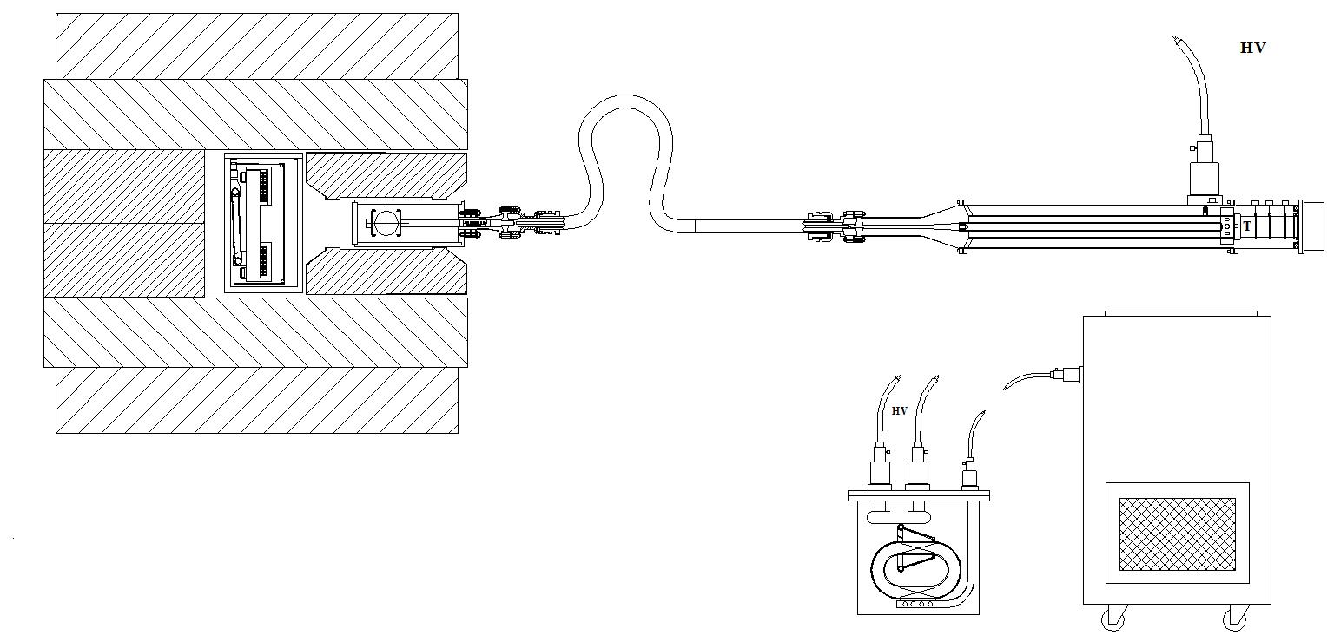
Figure 23. The kicker set up. One can imagine vertical positioning of the pulser.
The pulser with Blumlein generator can stand vertically if necessary. As we mentioned already, a single generator can feed up to four kickers in parallel. This is useful as it allows for matching of the impedance of the kicker line (which might be up to 100Ohm) with the generator, whose impedance is lower. For splitting the pulse, the scheme represented in Fig.16 can be used.

Measurements of the pulsed field in the kicker aperture.
Mostly, influence from the power supply is going through the electrostatic induction to the signal coil. Special coils, insensitive to the electric field, can be used for mapping the field generated by the kicker. The concept of such a coil is represented in Fig. 24.
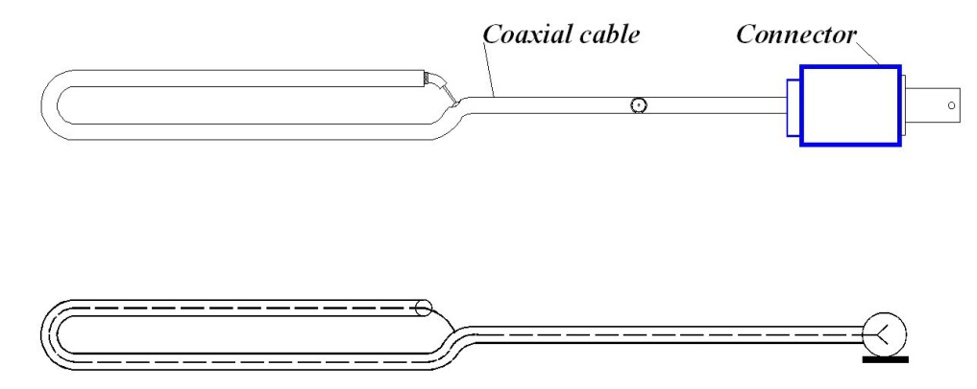
Figure 24. The coil for measurements in the fast changing field.

With a coil shown in Fig.24 the measurements can be carried out with magnetic field duration at the nanosecond level [4].
To get an output signal, which is proportional to the magnetic field value, the signal from the coil needs to be integrated. Integration could be active with electronics circuit or passive if the signal is very fast of big enough, so one can to sacrifice the sensitivity.
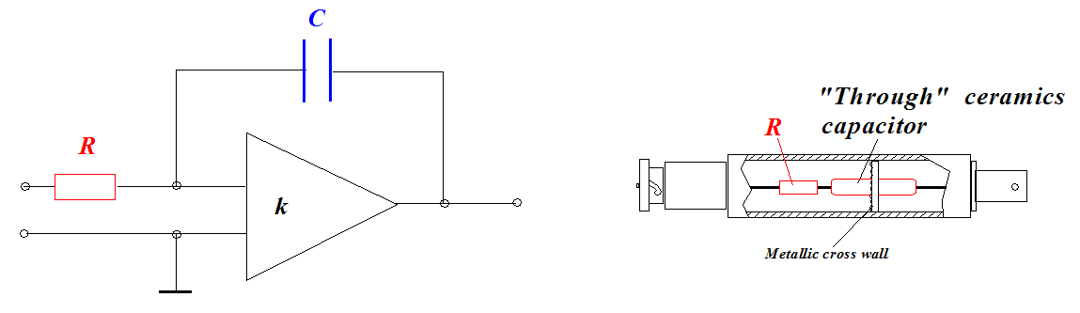
Figure 25: Integrators used with coils.

In Fig. 25, left, the active integrator consists on amplifier with amplification k. Output signal here is
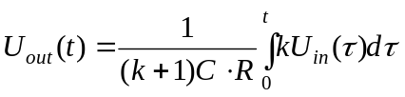. (18)

So it looks like an RC integrator with the capacitor effectively k times bigger. This type of integrator can be used with fast operational microchip. The passive integrator shown in Fig. 25 operated successfully with the pulses of nsec duration [4].
The NMR cartridge can me modified slightly to be able to carry a system of measuring coils located at the non-metallic crossbar, attached to the cartridge.

INTEGRATED FIELD MEASUREMENT SYSTEM WITH Bi WIRE RUNNING ALONG THE RING
Sensitivity of Bismuth resistance on magnetic field -Magneto-Resistivity- can be used in controlling stability of integrals of magnetic field along the beam trajectory. Bismuth wire technique is useful for control the integrated field. In this case the wire is located in the aperture along the pass, where the field should be integrated. Wire, located at the pole of the magnet, runs along the ring, see Fig.26. Few wires can be located for the measurements of such integrals along different radiuses. Such technique allows control the field integral between NMR runs.
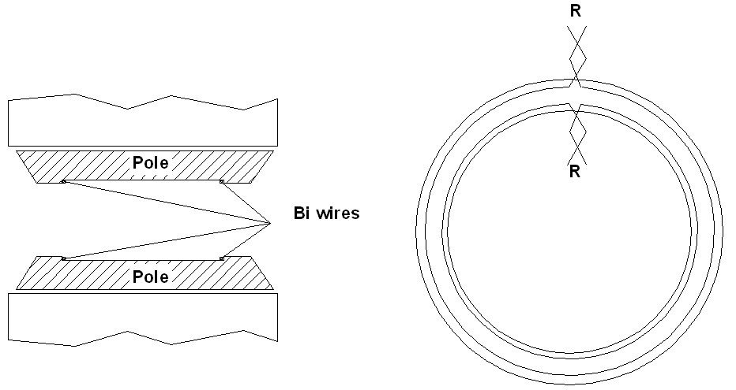
~7.1m
Figure 26. Measurement of the field integral along the four loops located on the poles.

Necessary precautions need to be taken into account as the wire is rather fragile. So the wire should be placed in the holders, preventing the damage. These holders might be designed as a small aperture tubes or flexible strips (of fiberglass/glass for example) with the wire sitting in.
Resistance R of the wire having the length l and radius a could be expressed as the integral over the area of wire
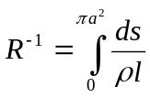. (19)

Here  –is the specific resistance which depends on magnetic field, ds is unit area
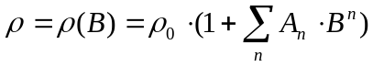, (20)
where 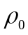–is a specific resistance at zero field, 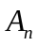–are expansion coefficients. In low field, n2 is dominating. In strong field the term with n=1 becomes a main one in the sum. If the field is pretty homogenous, so the field variation across the wire could be neglected, then the resistance comes to the following value
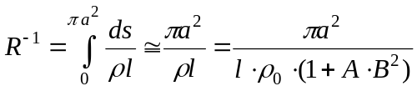. (21)
Usually this wire requires calibration in known field, as in reality the magnetic field dependence in transition region is rather complicated. The A value is of the order 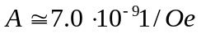 was found experimentally. Other parameters of Bismuth are shown in Table 1.

Table 2. Properties of the Bismuth wire.
Density | 9.747 g/cm³
Coefficient of linear expansion | 1.35 10⁻⁵ 1/degree
Melting temperature | 273.1 ºC
Boiling temperature | 1420 ºC
Heat conductivity | 0.18 Cal/cm/s/ºC
Heat capacity | 0.031 Cal/g/ºC
Elasticity | 3.19 10¹⁰ N/m²
Specific resistance, 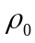 | 1.14 10⁻⁴ Ohm· cm
Resistance thermal sensitivity | 4.2 10⁻³ 1/ºC
Magnetic susceptibility, 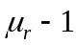 | -16.7·10⁻⁵

For the references, the magnetic susceptibility of Copper is -0.92·10⁻⁵ ; Aluminum has +2.2·10⁻⁵, so in principle, it should be taken into account.
Technology of fabrication the wire well developed at Cornell. The photo of one model of extruder prototype is represented in the Fig. 27 below.

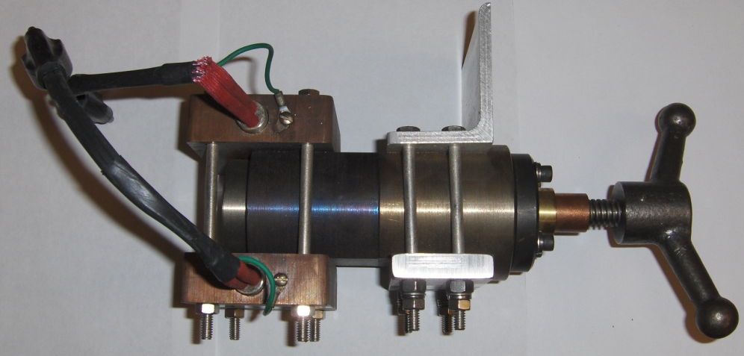
Figure 27. Extruder for the Bismuth wire. Electrical heaters, visible at the left, help in the process.

The extruder allows extrusion of 0.1 mm wire. This wire can be covered by an enamel and attached to the protective film. Set of few wires running along the ring give the magnetic field integral in situ. Accuracy of the field measurements associated with the accuracy of measurements of resistance and stability of temperature.
For calibration of loop with Bismuth wire, positioned in a dipole, the existing NMR probes can be used.
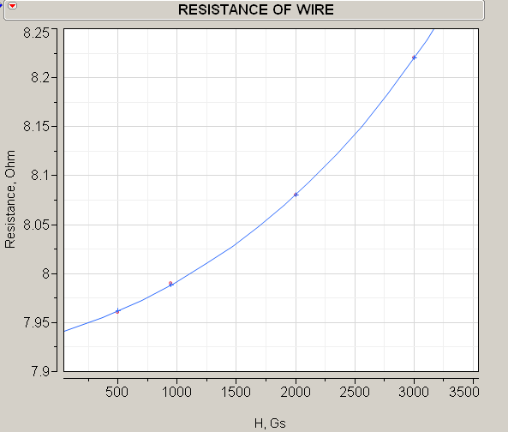
Figure 28. Resistance of the Bismuth wire sample.
We shall perform the calculations, design and the prototyping the setup.

All parameters represented in the text above are preliminary and will be specified in detail during the first stage of work.

SCOPE OF WORK
At a period of FY2012, Cornell will provide:
● Analyses of injection efficiency;
● Optimization of injection;
● Analyses of existing kicker system performance with 3D codes;
● Reinstallation the E-821 hardware at Cornell and test;
● Suggest primary modification of the pulse generator and the kicker;
● Analyses of new generator;
● Full drawings of the new generator and kicker with mechanical switching polarity;
● Full drawings and modification procedures for making the hole through the inner cryostat;

● Assembling a full scale prototype of a new pulser and the kicker;
● Test the prototype and the kicker together;
● Design of Blumlein pulsed system able generation of bi-polar pulses without mechanical switching;
● Test the prototype of Bi wire integrated measurement system, if requested.

REFERENCES
[1] The New (g-2) Experiment: A proposal to Measure the Muon Anomalous Magnetic Moment to ±0.14ppm Precision.
[2] E.Efstathiadis, et.al., “A fast Non Ferric Kicker for the Muon (g-2) Experiment”, NIM A 496 (2003) 8-25.
[3] A.Mikhailichenko, “Fast Kicker”, CBN 09-03, CLASSE, August 2009.
[4] A.A. Mikhailichenko, V.F. Turkin, “Miniature Pulsed Deflector”, (Novosibirsk, IYF). May 1977, 2 pp, Published in Instrum.Exp.Tech. 20 (1977) 632-633.
[5] L.Roberts, “Kicker R&D Work Plan: Options and Time Estimates”, New Muon (g-2) Technical Note #003, August 14, 2008.
[6] A.D. Blumlein, “Apparatus for Generating Electrical Impulses”, U.S. Patent No. 2,496,979 Feb 7(1950).

Dow Corning 561 Silicone Transformer Liquid presents a much lower fire hazard than other transformer fluids. It is difficult to ignite, but if it should ignite, it produces less heat and smoke and virtually extinguishes itself when the external source of heat is removed.
Alan Dower Blumlein (29 June 1903 – 7 June 1942) was a British electronics engineer, notable for his many inventions in telecommunications, sound recording, stereo, television and radar. He received 128 patents and was considered as one of the most significant engineers and inventors of his time (Wikipedia).
Colloidal suspension of a Ferrite nano-powder in the oil-type solvent. Available in industrial quantities. Cornell has experience in usage of this liquid for magnet performance improvement and for cooling, simultaneously.

